Bodywork for Wellness
Manual Physical Therapy & Therapeutic Massage, PLLC
1 Pine West Plaza, Ste 111, Washington Ave Extension
Albany, NY 12205 Ph:(518)424-6487
Winter 2019 Newsletter

A New Location for the Office: As of February 4th, 2019, Bodywork for Wellness will be located at
1 Pine West Plaza, Suite 111, Albany NY 12205. Below are some pictures and directions, to help you get familiar with the new location. Please use Google Maps, with the address 1 PINE WEST PLAZA, that will take you to the closet door to the. If you use Mapquest you will need to put in 315 WASHINGTON AVENUE EXTENSION.

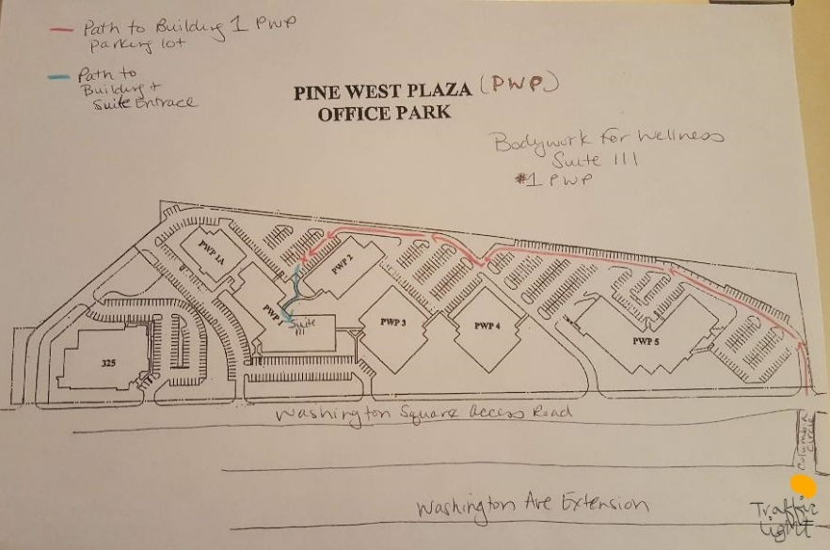
Parking Lot and Building overview Plaza Entrance Sign
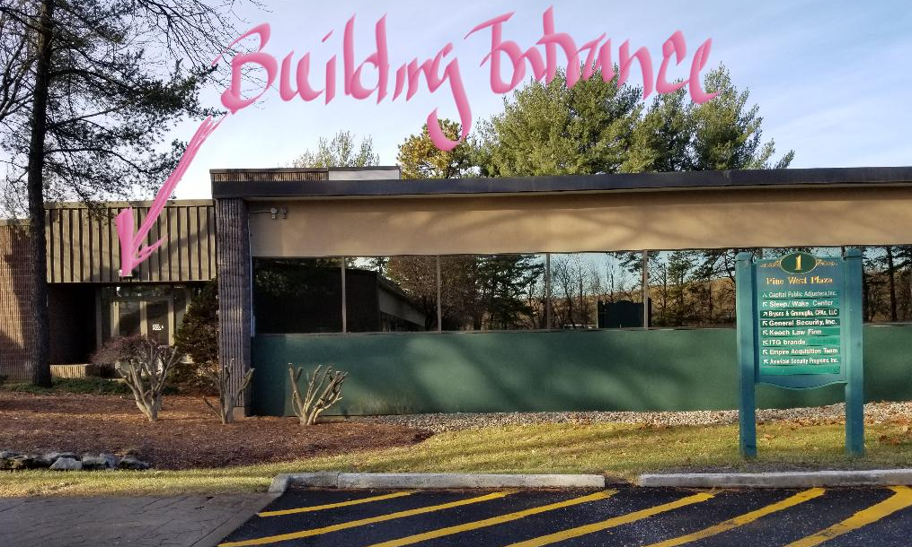

Directions
From the South, and West, Find your way to I-90 Merge onto I-90 Towards Albany, then take Exit 2 for Washington Ave towards U Albany, Take a right onto Washington Ave follow for 2.6 miles, this road becomes Washington Ave Extension. AT the traffic light, Just past Treviso, the Italian American Community Center and the large illuminated sign, you will turn right onto Columbia Circle Dr. You will see the sign for Pine West Plaza, follow road straight ahead and follow signs for building 1, you will pass one speed bump, then turn right to continue to building 1. After passing over a 2nd speed bump parking for Building 1 will be on the left. Follow signs for Bodywork for Wellness. Once inside the building suite 111 will be on your left.
From the East: Take !-90 West to Exit 2 Fuller Road towards U Albany. At the end of the ramp enter the traffic circle and take the 3rd Exit onto Fuller Road. Go .1 mile, at the next traffic circle take the 1st exit/ramp for Washington Avenue East. Merge onto Washington Ave, which becomes Washington Ave Extension. Drive for 2.1 miles, At the traffic light, just past Treviso and Italian American Community Center and the large illuminated sign, You will turn right onto Columbia Circle Dr. Straight ahead will be the sign for Pine West Plaza. Follow road around the back of the complex following signs for building 1. You will pass one speed bump and then turn right to continue to building 1. After passing over a 2nd speed bump the parking for Building 1 will be on the left. Follow signs for Bodywork for Wellness. Once inside the building suite 111 will be on your left.
From the North: Take I-87 South, then take the exit for Crossgates Mall (Exit 1D). Bear to right at the light at the end the ramp onto Crossgates mall road. At the first traffic light turn right onto Access road. Take the 1st left for Washington Avenue Extension ramp. Drive for 1.4 miles, at the traffic light, just past Treviso and Italian American Community Center and the large illuminated sign, You will turn right onto Columbia Circle Dr. Straight ahead will be the sign for Pine West Plaza. Follow road around the back of the complex following signs for building 1. You will pass one speed bump and then turn right to continue to building 1. After passing over a 2nd speed bump the parking for Building 1 will be on the left. Follow signs for Bodywork for Wellness. Once inside the building suite 111 will be on your left.
From 155 East or West. Turn onto Washington Ave Extension, at the 1st traffic light turn left onto Columbia Circle Drive . Straight ahead will be the sign for Pine West Plaza. Follow road around the back of the complex following signs for building 1. You will pass one speed bump and then turn right to continue to Building 1. After passing over a 2nd speed bump the parking for building 1 will be on the left. Follow signs for Bodywork for Wellness. Once inside the building suite 111 will be on your left.
Restrooms:
When you come in to the lobby via the door pictured above, to the right down the hall are a set of ladies’ and men’s rooms. These have standard stalls. If you need a handicapped accessible restroom, from the lobby head to the left, pass suite 111, and ahead on the right will be a hallway with ladies’ and men’s rooms with full handicap stalls.

